Design
Design Objectives:
The main objectives of this section are required features which are to be incorporated into the system. This has been established in the User Requirements list which has been agreed by the stakeholders.
The features of the system are going to be analysed in detail using Ubiquitous Language so that it could be understood and realized by all the technical and nontechnical members of the Project Team (All the Stakeholders).

User Interface:
The size of the Application Window will be initially set for the 1366 X 768 pixels which is the lowest screen resolution available for Laptop or Monitors.
So, the size will be set as 1200 X 750 pixels but it will be auto sized as the windows is maximised.
In addition to the Application Window, Authentication window will be displayed before the Application window become visible.
Size of the Authentication window is set to 500 X 200.
Background Colour is set to Light Blue.

The User Interface will be divided into four windows or panes by grouping the related GUI elements into the appropriate pane.
They are as follows:
- Header Pane: Size will be 1200 X 100 with the Colour Light Blue
- Navigation Pane: Size will be 100 X 600 with the Colour Light Grey
- Content Pane: Size will be 800 X 600 with the Colour Light Grey
- Footer Pane: Size will be 1200 X 100 with the Colour Light Grey

The Interspacing of the panes are set to 5 pixels for both x and y.
All Buttons background colours will be set to blue and forecolour will be set to white.
Some of the buttons are set to use the images (Exact image will be decided later).

There will be an appropriate image (Application Logo) which will be displayed in the content pane at the start of the application.

Input Considerations:
- The user will have the ability to the add new Questionnaire through the User Interface which can be achieved by displaying a Form in the Content Pane.
- The user will have the ability to view, edit or remove the existing Questionnaires through the Interface.
- The user will have the ability to enter the search query through the User Interface.
- The user will have the ability to enter the authentication details at the start of the application.

Processing Considerations:
- Inputted Questionnaires must be correctly extracted and stored into the corresponding entities (Participants, Relationships, Interests) so that it can be persisted into the back-end database.
- Search query must be correctly parsed and perform the correct search.
- Clicking Next Button in the Footer Pane which should navigate through the tabular list in a forward direction until the last record and then stop.
- Clicking Previous Button in the Footer Pane which should navigate through the tabular list in a backward direction until the last record and then stop.
- Authentication details must be verified with Pre-stored user details.
- Processing an External text File to extract Form’s Properties so that diferent forms can be built dynamically
- User’s ACL after Authentication, correctly render the appropriate components of the User interface.
For example, Guest/Author User should not see the search form, Reader /Researcher should not have functionality of Adding or Removing Quesionnaires.
- Added Questionnaires should be assigned a Relationship Fitness Value .
- The Top X Participants or Bottom x Participants must be searched using an rank algorithm based on the Relationship Fitness Value .

Output Considerations:
- User should be able to view the list of Questionnaires in a tabular format in the Content Pane. The tabular data should display the values from the Participant entity. Those values will be:
    - Id, Age, Gender, Ethnicity, Occupation, County, Origin, Education.
- As the user navigate through the list, the contents of the Questionnaire should be displayed using tabbed pane for the three different entities (Participant, Interests, Relationships)
- Clicking “View *** Questionnaires” buttons determine the contents of the tabular list.
- Search Query determine the contents of the tabular list as well.
- Authentication failures must be displayed as message in red colour at the bottom of the Authentication window.

Mock-up Design

User Interface:

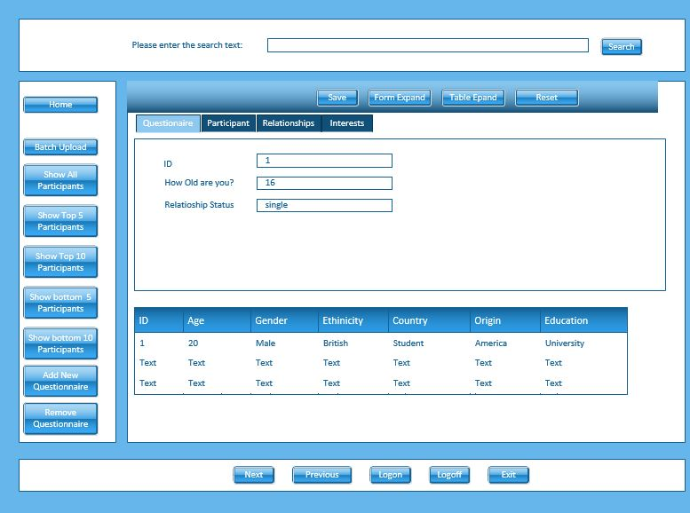

Authentication Window:

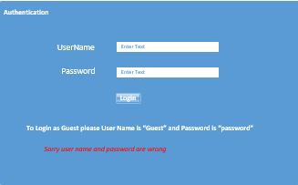
Four Actors have been identified for the Use Cases of the application.
They are:
- Guest or Author
- Reader
- Editor
- Admin

Use Case:
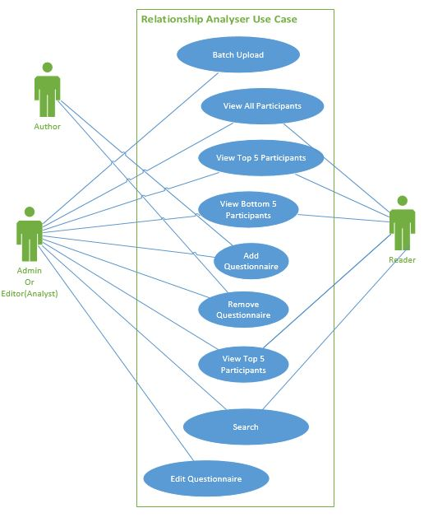
User Review of Objectives:
All five of my users have reviewed and agreed to the above objectives.

The following section mainly focussed on decomposing application into manageable modules by their functionalities.
Also, it will provide coarse and fine details of each module.
To make the decomposition effective, Model View Controller(MVC) Design Pattern will be applied during the process.
The main purpose of the applying MVC, is identifying the separation of concerns and model it as a separate functional blocks (modules) so that modules can be tested in isolation for their both functional and behavioural. Also, it minimises the tight coupling (or dependencies) among modules.
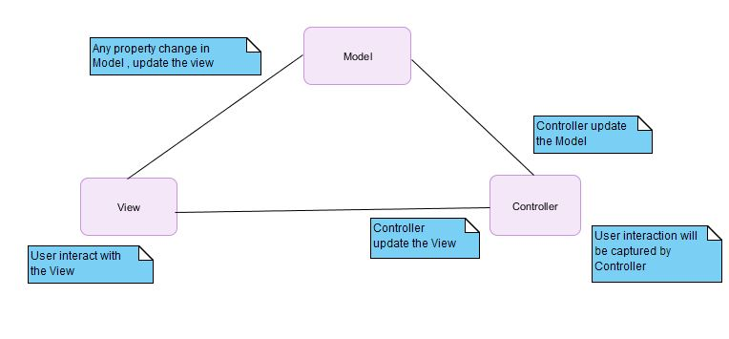

Model:
The main and core data which the application, intended to analyse are collection of Questionnaires from participating people (Participants).
Captured answers from the Questionnaire carefully identified and categorised into three different entities.
Domain Model | Database Entities | Description
Participant | Participant | Meta data of the Questionnaire
Interests | Interests | data related to the interests of a person for having successful relationship
Relationships | Relationships | data related to the relationship of the person
Questionnaire |  | Whole data
User |  | It captures the Logged User information.
SearchQuery |  | It captures the query information.

UML Class diagram of the Domain Entities
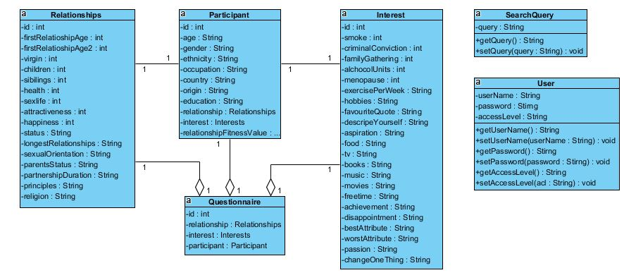

As it is shown above, Questionnaire entity acts as Aggregate Root for Participant, Interests, Relationship entities.
Repository Pattern will be used to certain extent to separate the business logic from the underlying database.
Basically, Repository is acting like an In-Memory Collection of Domain Entities and hiding any interactions to the underlying Database layer. It allows testing possible without having any Persistence Store (Database) by mocking up a database in the memory.
Questionnaire entity will not be stored in the Repository(Database) but the system extract the information from the Questionnaire entity and storing them into Participant, Interests, Relationships entities for persistence.
Questionnaire will be used only for capturing and displaying information.

UML Class diagram for the Repository:
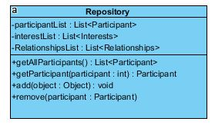
Finally, the computational algorithm which will be used to assign a numerical score to the Participant entity (relationshipFitnessValue) is delegated to a Domain Service called RelationshipRatingService.
The service is critical to the application and it provides,
- A computational algorithm to assign a numerical value for relationshipFitnessValue of Participant entity using attributes from Relationships entity.
- It sorts the Participants using the relationshipFitnessValue and serves any modules with the Participants List of any numbers (1...n) either descending or ascending.
UML Class Diagram for the RelationshipRatingService.
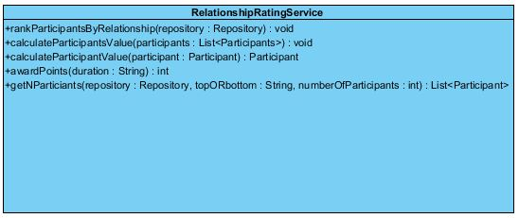
The Pseudo code for calculating the FitnessValue (relationshipFitnessValue):
Which is “calculateParticipantValue (Participant participant)” method.

LOOP through participant list
PICK a participant
INITIALISE fitness value
ADD happiness value
ADD sex life value
ADD relationship value
ADD relationship length
ASSIGN fitness value to participant
REPEAT
The Sequence diagram below shows,
- Invocation of methods during the call of RelationshipRatingService by Repository class.
- Invocation of method getNParticipant by GUI during a search.
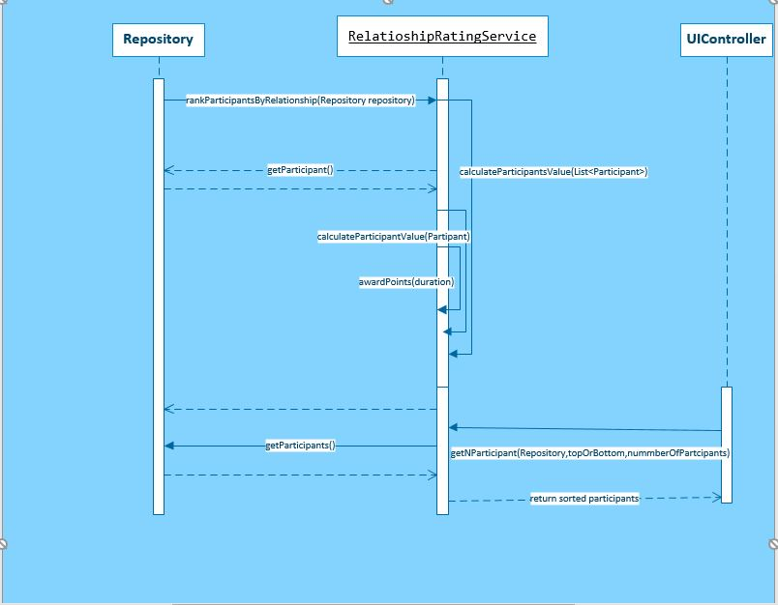
Pseudo Code for creating a Questionnaire Instance:
Create Participant Instance.
Create Interest Instance
Create Relationship instance.

Pseudo code for setting and getting an Attribute of the Questionnaire class:
Check what entity this attribute (say: age) belongs to (say Participant)
Call the Participant setter method by passing the attribute Value as parameter.
participant. setAge(attributeValue)
participant. getAge() for getting the attribute value.
Testing Entities:
As it is described earlier, Questionnaire entity is stateless (doesn’t store any state for the attributes) but have reference to the Participant, Interests, Relationships entities.
So, any creation of Questionnaire, should create other three entities, any setter methods that we used to set Questionnaire, should set the respective attributes of Participant, Interests, Relationships entities.
There are forty-four questions formulate the Questionnaire
- Participant entity has seven attributes from Questionnaire.
- Interest entity has twenty-two from Questionnaire.
- Relationships entity has fifteen from Questionnaire.

Test Data:
Attribute Name | Questionnaire  Test attributes values | Questionnaire setter methods | Expected Participant Attribute value | Expected Interest Attribute value | Expected Relationships Attribute value
Age | 25 | setAge | 25
Status | single |  |  |  | single
FirstRelationship Age | 16 | setFirstRelatioshipAge |  |  | 16
Virgin | 1 | setVirgin |  |  | 1
LongestRelationship | 3 years | setLongestRelationship |  |  | 3 years
Gender | Male | setGender | Male
SexualOrientation | Hetrosexual | setSexualOrientation |  |  | Hetrosexual
PartnershipDuration | 3 years | setPartnershipDuration |  |  | 3 years
Occupation | Graduate Student | setOccupation | Graduate Student
Ethnicity | Asian | setEthnicity | Asian
Children | 0 | setChildren |  |  | 0
Siblings | 4 | setSiblings |  |  | 4
ParentsStatus | Married | setParentsStatus |  |  | Married
Health | 3 | setHealth |  |  | 3
SexLife | 4 | setSexLife |  |  | 4
Attractiveness | 4 | setAttractiveness |  |  | 4
Country | UK | setCountry | UK
Origin | UK | setOrigin | UK
Education | University | setsetEducation | University
ExercisePerWeek | 2-4 days a week | setExercisePerWeek |  | 2-4 days a week
Hobbies | No Hobbies | setHobbies |  | No Hobbies
Smoke | No | setSmoke |  | No
AlcoholUnits | 0 | setAlcoholUnits |  | 0
CriminalConviction | No | setCriminalConviction |  | No
Menopause | No | setMenopause |  | No
Happiness | 4 | setHappiness |  |  | 4
Principles | Family Honesty grattitute | setPrinciples |  |  | Family Honesty grattitute
FavouriteQuote | nothing | setFavouriteQuote |  | nothing
DescribeYourself | loyal | setDescribeYourself |  | loyal
Aspiration | Finishing my PHD | setAspiration |  | Finishing my PHD
Tv | Friends | setTv |  | Friends
Movies | Comedy | setMovies |  | Comedy
Music | Rock | setMusic |  | Rock
Books | Mystery | setBooks |  | Mystery
Food | Italian | setFood |  | Italian
FreeTime | Relaxing | setFreeTime |  | Relaxing
Religion | Christianity | setReligion |  |  | Christianity
FamilyGathering | Yes | setFamilyGathering |  | Yes
Achievement | Getting into University | setAchievement |  | Getting into University
Disappointment | I don’t know | setDisappointment |  | I don’t know
BestAttribute | Patience | setBestAttribute |  | Patience
WorstAttribute | Overreact | setWorstAttribute |  | Overreact
ChangeOneThing | Nothing | setChangeOneThing |  | Nothing
Passion | Helping Others |  |  | Helping Others

Testing the RelationshipFitnessValue:
Use the same data for Questionnaire as above.
Using the algorithm, the participant.relationshipFitnessValue must be 16.

View or GUI or Presentation Layer:
Java Swing Technology has been chosen to design the GUI.
The top-level View has been envisaged as a conventional Four Panes User Interface (as shown earlier in the Mock-up design) which comprises of Header Pane, Navigation Pane, Footer Pane, Content Pane.

All Panes are inherited from JPanel(Swing Component).
Header Pane: Provide the Search functionality by allowing user to enter free text to perform Free Text Search and Predefined Search (such as Top10 or Top5 0r TopN ) using RelationshipFitnessValue.
Search engine could be designed to cater very complex searches using complex algorithms but due to the time constraints moderate complexity has been envisaged.

Navigation Pane: This comprises of most of the buttons (JButton- Swing Component) to perform various data mining (some of them are overlapping with the previous functionalities) such as Top5 ,Top10, bottom5, bottom 10 on the RelationshipFitnessValue. It also provides the functionality of Add, Modify, Delete functionality of the Root Entity Questionnaire.

Footer Pane: This comprises of buttons to facilitate the users to Navigate through the Collection of Questionnaires, such as Next, Previous also perform tasks Logon and Log Off.

Content Pane: This is the main GUI Component display the Output in both Tabular and Form formats. This Pane comprises of three separated panels vertically arranged. They are
Tool Panel - containing buttons to manipulate the form data to be persisted to the Repository , utility buttons expand and reset to vary the size of respective Panels.
Tabbed Pane Panel – This comprises of four different forms for displaying respective entities to the user.
Tabular Display – This display the Participant entity (Meta data of the Questionnaire) in a tabular format.

There are several modules (classes) have been realized at higher level to represent the above Panes and they are:

ContentPane (Inherited from JPanel – Swing Component)
NavigationPane (Inherited from JPanel – Swing Component)
FooterPane (Inherited from JPanel – Swing Component)
SearchPane (Inherited from JPanel – Swing Component)
SearchPane comprises GenericForm class (will be explained later) to add the form functionality.

View class is realized such way it analogues to the top-Level GUI component or the User interface. This will hold direct references to all the next level GUI elements (all the Panes ) as described above.

UML Diagram for the View with all the Sub Modules:

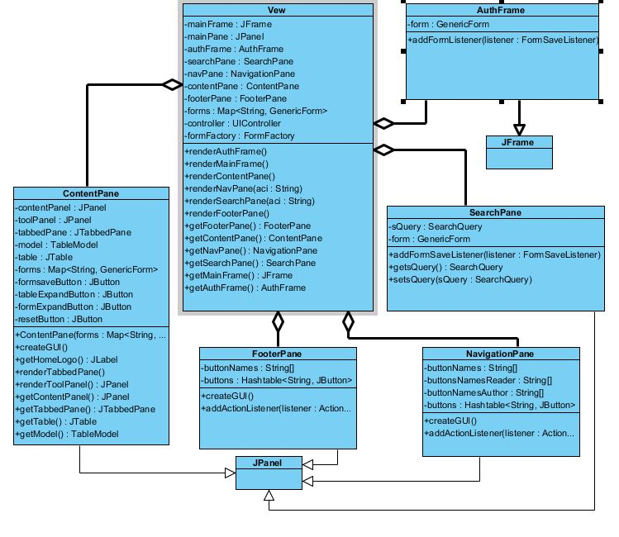

View module(class) responsible for the rendering of all the submodules as shown above but it delegates the rendering to its submodules as and when it is required.

It would be sensible to explain about AuthService module at this stage.
This module is not part of the GUI, but it will be used to authenticate users to access the application.

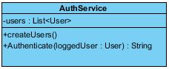

Pseudo code for displaying the GUI:
Create the View .
Invoke renderAutheFrame method to display the Authentication Window.
When user clicks logon, call the FormSaveOccured method using the listener of UIController module.
Invoke the FormSaveOccured method in UIController module
Capture the user’s credentials using User object.
Call the Authenticate method of AuthService to authenticate.
On Failure , Go back to AuthFrame present user with the logon error message.
On Success , get acl (access control) of the user.
Use the acl to render the Mainframe using the renderMainFrame of the View.
Invoke renderMainFrame of View
Invoke renderNavPane to render NavigationPane
Invoke renderSearchPane to render SearchPane
Invoke renderFooterPane to render FooterPane
Invoke ContentPane to render ContentPane
Invoke renderToolPanel in ContentPane to render ToolPanel
Invoke renderTabbedPane in ContentPane to render TabbedPane.
Invoke renderTable in ContentPane to render the Tabular List.
Rendering completed
Rendering completed
Rendering Completed.

High Level Sequence Diagram of rendering View module(User Interface):

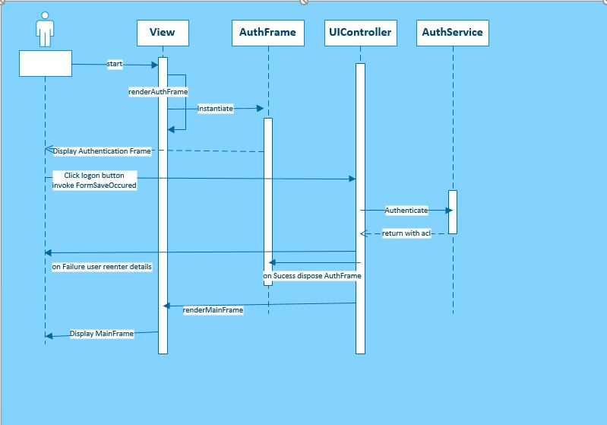

Test Data for testing AuthService:
Create a User object with username=”Guest” , password=”password” , acccessLevel=”Author”
Add this user to the Users List in the AuthService.

Simulate login by creating another User object with the following:
- username=”Guest” password=”password1” and Invoke AuthService.authenticate(user)
expected return value should be null.
- username=”Guest” password=”password” and Invoke AuthService.authenticate(user)
expected return value should be “Author”.

User Roles and their Access Level with the GUI elements:

Navigation Pane(Buttons) | Author or Guest | Reader | Editor , Admin
Home | Yes | Yes | Yes
Batch Upload | No Access | No Access | Yes
Show All Participants | Yes | Yes | Yes
Show Top5 Participants | No Access | Yes | Yes
Show Top10 Participants | No Access | Yes | Yes
Show Bottom5 Participants | No Access | Yes | Yes
Show Bottom10 Participants | No Access | Yes | Yes
Add New Participant | Yes | No Access | Yes
Remove New Participant | Yes | No Access | Yes
Search Pane | Author or Guest | Reader | Editor , Admin
Search Box | No Access | Yes | Yes
Content Pane (Tool Panel) | Author or Guest | Reader | Editor , Admin
Save Button | Yes | No Access | Yes
Other Buttons | Yes | Yes | Yes
Footer Pane | Author or Guest | Reader | Editor , Admin
All Buttons | Yes | Yes | Yes

The above table can be used as Test Data for verifying the GUI elements for different login for
- Author (Guest)
- Reader
- Editor(Analyst) and Admin

Lastly, there will be a complex feature incorporated with the design to increase the flexibility and reusability of the application with minimal refactoring of the code.

The Thought process of such a design is explained below.
The application is mainly based on collecting answers for set of predefined questions from users. So, the application should provide a form based interface to accommodate these questions and answers.
How would it impact of the form design ?
- If the question is rephrased
- If the options for Questions changed (Say for combo Box or List Box or Radio button fields)
- If the colour of the form changed
- If four columns used instead of two columns
- If different style of TextBox need to be applied
- If size of fields dynamically to be changed
- If different validation need to be applied on fields.

Would the form have to be redesigned whenever such requirement arises?
Furthermore, As the questions have varying length, sometimes it could become very long. So, accommodating these long literals into code is very cumbersome and error prone.
Especially, when there would be a demand for multiple forms, then the number of form design increase as well.

In the light of the above analysis, it has been concluded that:
- The data of the form (questions) and all other attributes must be separated from form and stored outside the code in a text file.
- Design a form as Generic Form to accommodate all the features that described as above.
- Design a Form Configurator to store the form related data and attributes. This will be populated dynamically from the text file.
- Hence It can be realised that above design caters generation of numerous forms from only two modules (classes) Generic Form and FormConfigurator .

The various modules envisaged to provide the solutions for the above problems are:

GenericForm Generic User interface.
FormConfigurator Stores all the necessary data to make the template as a Form such as Participant Form, Relationships Form, Interests Form and Questionnaire form.
FormFactory This is used to create FormConfiguration and GenericForm classes from a text file.
ConfigAttribute This is used to store any data which the FormFactory reads it from text file as an (Attribute Name, Attribute Value ) pair for processing to create FormConfigurator.
MappingService If Multiple forms share the same fields and fields labels , this service provide the flexibility of defining these fields and labels once and use it multiple times in different forms.

Class Diagrams for the GenericForm Design:

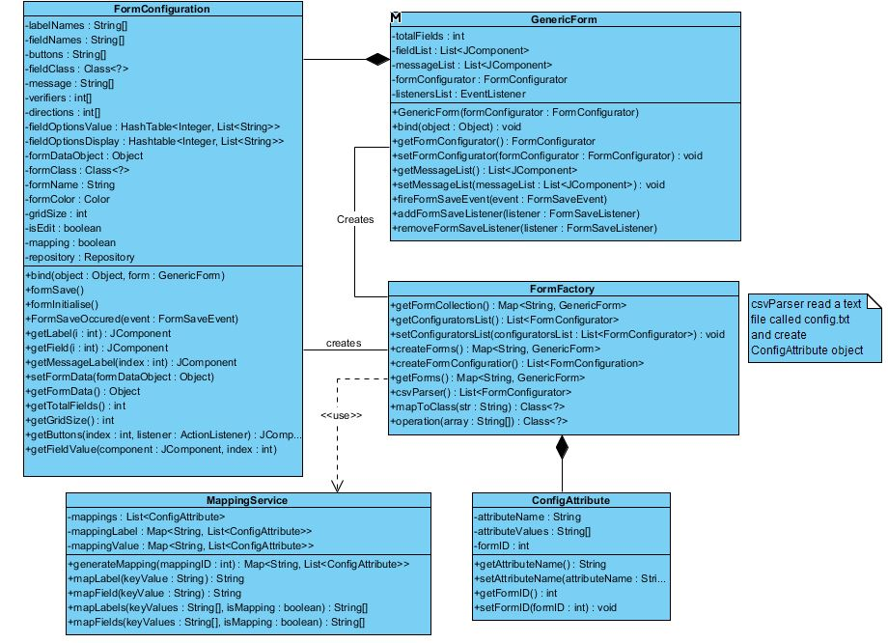

Also various classes have been realised as lower level GUI elements such as
RadioButtons (Inherited from JPanel) to display the JRadioButtons as group
Custom Border (Inherited from Abstract Border Swing component) to visually decorate the border.
RoundedTextField (Inherited from JTextField Swing component) to visually decorate the JTextField.
RoundedTextArea (Inherited from JTextArea Swing component) to visually decorate the JTextArea.

JTable (Swing Component) has been chosen to display the tabular data of the Participant entity.
Table class is designed (inherited from JTable) to add the additional functionality for the application purposes such as Table columns customisation, adding of JTable specific listeners (ListSelectionModelListener , TableModelListener).

Validation logic has been realized for the input controls, such as
- TextVerifier : Validate against non-empty string
- NumberVerifier : Validate against non-numeric characters.
Two classes of each verifiers have been thought about.
The details of the logic will be provided later.

The following contents is copied from a sample text file called “Config.txt” which will be used to populate GenericForm.

******** Any Form Configuration **************************
formName=Form Name has to be enterd here
This is the format of any form block. To create a new form , The attributes on the left have to be properly populated
labelNames=All the label Names for the Input Fields
fieldNames=All the Field Names of the Class inrepresent
fieldClass=Class Type of the Input Fields
fieldSize= Size of the Input Fields
verifiers=Input Verifiers for the Input fields
directions=Direction of the Fields, Vertical or Horizontal
formClass=The Class of the entity that form relates to
gridSize=No of the columns of the form
options1=options Literals
options2=option Literals
optionsV=assignment of option literals to the Field as pair
optionsD= assignment of option literals to the Field as pair
color=Background color of the form

************* ************************ Start Of Mapping *****************************

************************************* Label Mapping ************************************
action=mapping
1.0=ID
1.1=How old are you?
1.2=what is your relationship Status?
1.3=How old were you when you had your first relationship?
1.4=Are you a virgin?
1.5=How long was your longest relationship?
1.6=What is your Gender?
1.7=What is your sexual orientation?
1.8=How long have you spent with your partner?
1.9=What is your Occupation?
1.10=What is your ethnicity?
1.11=How many children do you have?
1.12=How many siblings do you have?
1.13=What is the relationship status of your parents?
1.14=How would you rate your health (from 1 to 5)?
1.15=How would you rate your sexual life (from 1 to 5)?
1.16=How would you rate your attractiveness (from 1 to 5)?
1.17=Where do you live(Country of Residence)?
1.18=Where are you from (Country of Origin)?
1.19=What is the highest level of education you have completed?
1.20=In a typical week - how many days do you exercise?
1.21=What are your hobbies?
1.22=Do you smoke?
1.23=About how many alcoholic drinks do you have each week?
1.24=Do you have any criminal convictions?
1.25=Have you experienced menopause?
1.26=How happy are you (from 1 to 5)?
1.27=What values and principles are most important to you?
1.28=What is your favourite quote?
1.29=Using single words or phrases, how would you describe yourself?
1.30=What marriage values and principles are most important to you?
1.31=Where do you see yourself in 5-10 years?
1.32=What are your favourite TV shows?
1.33=What are your favourite movies?
1.34=What is your favourite kind of music?
1.35=What types of books do you read?
1.36=What is your favourite food?
1.37=What do you do in your free time?
1.38=What are your spiritual beliefs?
1.39=Is participation in family gatherings and celebrations important to you?
1.40=What is your greatest achievement?
1.41=What is your greatest disappointment?
1.42=What is your best attribute?
1.43=What is your worst attribute?
1.44=If you could change one thing about yourself, what would it be?
1.45=What is your greatest Passion?
1.46=Relationship Value
1.47=User Name
1.48=Password
1.49=Please enter search text

************************************* Field Mapping ************************************

action=mapping
1.0=Id
1.1=Age
1.2=Status
1.3=FirstRelationshipAge
1.4=Virgin
1.5=LongestRelationship
1.6=Gender
1.7=SexualOrientation
1.8=PartnershipDuration
1.9=Occupation
1.10=Ethnicity
1.11=Children
1.12=Siblings
1.13=ParentsStatus
1.14=Health
1.15=SexLife
1.16=Attractiveness
1.17=Country
1.18=Origin
1.19=Education
1.20=ExercisePerWeek
1.21=Hobbies
1.22=Smoke
1.23=AlcoholUnits
1.24=CriminalConviction
1.25=Menopause
1.26=Happiness
1.27=Principles
1.28=FavouriteQuote
1.29=DescribeYourself
1.30=What marriage values and principles are most important to you?
1.31=Aspiration
1.32=Tv
1.33=Movies
1.34=Music
1.35=Books
1.36=Food
1.37=FreeTime
1.38=Religion
1.39=FamilyGathering
1.40=Achievement
1.41=Disappointment
1.42=BestAttribute
1.43=WorstAttribute
1.44=ChangeOneThing
1.45=Passion
1.46=RelationshipFitnessValue
1.47=UserName
1.48=Password
1.49=Query

**********************************************End Of Mappings********************************************************

******** Questionnaire Form Configuration
action=formParsing
mapping=on
formName=Questionaire
labelNames=1.0,1.1,1.2,1.3,1.4,1.5,1.6,1.7,1.8,1.9,1.10,1.11,1.12,1.13,1.14,1.15,1.16,1.17,1.18,1.19,1.26,1.27
fieldNames=1.0,1.1,1.2,1.3,1.4,1.5,1.6,1.7,1.8,1.9,1.10,1.11,1.12,1.13,1.14,1.15,1.16,1.17,1.18,1.19,1.26,1.27
fieldClass=1,1,1,1,5,1,5,1,1,1,1,1,1,1,5,5,5,1,1,1,5,2
fieldSize=5,5,20,20,20,20,20,20,20,20,20,20,20,20,20,20,20,20,20,20,20,20
verifiers=0,1,2,1,0,2,0,2,2,2,2,1,1,2,0,0,0,2,2,2,0,2
directions=0,0,0,0,1,0,2,0,0,0,0,0,0,0,1,1,1,0,0,0,1,0
formClass=project.Questionaire
gridSize=1
options1=Male,Female,Trans Male,Trans Female,Other
options2=Yes,No
options3=1,0
options4=1,2,3,4,5
optionsV=3,4,1,6,4,14,4,15,4,16,4,20
optionsD=2,4,1,6,4,14,4,15,4,16,4,20
buttons=Save,Save
color=186,219,241

******** Participant Form Configuration
action=formParsing
formName=Participant
labelNames=ID,How old are you?,What is your Gender?,What is your ethnicity?,What is your Occupation?,Country Of Residence,Country Of Origin,What is the highest level of education you have completed?,RelatioshipValue
fieldNames=Id,Age,Gender,Ethnicity,Occupation,Country,Origin,Education,RelationshipFitnessValue
fieldClass=1,1,5,1,1,1,1,2,1
fieldSize=5,5,20,20,20,20,20,25,5
verifiers=0,1,0,2,2,2,2,2,2
directions=0,0,2,2,0,0,0,0,0
formClass=project.Participant
gridSize=1
options1=Male,Female,Trans Male,Trans Female,Other
optionsV=1,2
optionsD=1,2
buttons=Save,Save
color=186,219,241

******** Relationships Form Configuration
action=formParsing
formName=Relationship
labelNames=ID,FirstRelationshipAge,Status,LongestRelationship,SexualOrientation,ParentsStatus,PartnershipDuration,Principles,Religion,Children,Siblings,Virgin,Health, Sex Life, Attractiveness,Happiness
fieldNames=Id,FirstRelationshipAge,Status,LongestRelationship,SexualOrientation,ParentsStatus,PartnershipDuration,Principles,Religion,Children,Siblings,Virgin,Health,SexLife,Attractiveness,Happiness
fieldClass=1,1,1,1,1,1,1,2,1,1,1,5,5,5,5,5
fieldSize=5,5,25,25,25,25,25,25,25,5,5,20,20,20,20,20
verifiers=0,1,2,2,2,2,2,2,2,1,1,0,0,0,0,0
directions=0,0,0,0,0,0,0,0,0,0,0,1,1,1,1,1
formClass=project.Relationships
gridSize=2
options1=Yes,No
options2=1,0
options3=1,2,3,4,5
optionsV=2,11,3,12,3,13,3,14,3,15
optionsD=1,11,3,12,3,13,3,14,3,15
buttons=Save,Save
color=186,219,241

******** Interests Form Configuration **************************
action=formParsing
formName=Interests
labelNames=Id,Alchocol Units,TV,Books,Best Attributes,Famil Gathering,Criminal Conviction,Hobbies, DescribeYourself,FreeTime,Disappointment,Excersise Per Week,Food,movies, Music, Worst Attribute,Smoke,Menopause,Favourite Quote,Aspiration,Achievement,Passion,Change One Thing?
fieldNames=Id,AlcoholUnits,Tv,Books,BestAttribute,FamilyGathering,CriminalConviction,Hobbies,DescribeYourself,FreeTime,Disappointment,ExercisePerWeek,Food,Movies,Music,WorstAttribute,Smoke,Menopause,FavouriteQuote,Aspiration,Achievement,Passion,ChangeOneThing
fieldClass=1,1,1,1,1,5,5,2,2,2,2,1,1,1,1,1,5,5,2,2,2,2,2
fieldSize=5,5,20,20,20,20,20,20,20,20,20,20,20,20,20,20,20,20,20,20,20,20,20
verifiers=0,1,2,2,2,0,0,0,0,0,0,2,2,2,2,2,0,0,0,0,0,0,0
directions=0,0,0,0,0,1,1,0,0,0,0,0,0,0,0,0,1,1,0,0,0,0,0
formClass=project.Interests
gridSize=2
options1=Yes,No
options2=1,0
optionsV=2,5,2,6,2,16,2,17
optionsD=1,5,1,6,1,16,1,17
buttons=Save,Save
color=186,219,241

******** logon Form Configuration
action=formParsing
mapping=on
formName=Logon
labelNames=1.47,1.48
fieldNames=1.47,1.48
fieldClass=3,3
fieldSize=25,25
verifiers=0,0
directions=0,0
formClass=project.User
gridSize=1
buttons=Login,Login
location=bottom
messageLabel=message,error
errorMessage=Sorry UserName and password are wrong
message=To Login as Guest please use "User Name is "Guest" and Password is "password"
color=186,219,241

******** Search Form Configuration
action=formParsing
mapping=on
formName=Search
labelNames=1.49
fieldNames=1.49
fieldClass=3
fieldSize=50
verifiers=0
directions=0
formClass=project.SearchQuery
gridSize=1
buttons=Search,Search
location=side
**color=186,219,241
color=225,232,237

Controller or Business Process Layer

Any classes which have been used to process the information for Model or View(GUI) , will be going to be analysed here.
Although the natural fit for the classes FormFactory, FormConfigurator, TextVerifier, NumberVerifier (previously covered in the Presentation Layer) should have been analysed in this layer , it had been covered in the previous section due to some interaction of the GUI Components.

The following classes have been identified as Services for the Application and Domain.

AuthService Application Service
RelatioshipRatingService Domain Service
MappingService Application service

RealtionshipRatingService is being called by the Controller Whenever Questionnaire entity need to be socially ranked (using a predefined algorithm over all three entities attributes – Participant, Relationships , Interests ) .
Controller uses AuthService to authenticate users to the application.

The following class UIController is the nerve system of the whole application.
All possible events had been well thought ,captured and modelled into UIController as Event Listeners.

UIController is designed to have references of View, Repository (Model), AuthService.
The following Listeners have been implemented in the UIController to capture the events when users interact with the GUI Elements of the View (User Interface).

ActionListener: This is a Swing Component(Interface) which will be fired to capture any buttons click events.
FormSaveListener: This interface is created along with the FormSaveEvent class to Capture any events generated by button click of the GenericForm class. This event will be fired every time user click the Save button.
ListSelectionModelListener : This is a Swing Component(interface) which will be fired to capture any selection of records(rows) of the Table.
TableModelListener: This is a Swing Component(interface) which will be fired whenever Table Model(Repository in the current system) is modified. TabelModelEvent is associated with this listener.

Development:

Add New Questionnaire Test:

